Genomic Sequences
Genome is the complete set of DNA in an organism, Contains both coding regions (genes) and non-coding regions.
Example: Human genome ≈ 3.2 billion base pairs.
Analogy: Think of a genome like a library.
- Each book as a chromosome.
- Each chapter as a gene.
- Some pages are blank notes (non-coding DNA).

Sequence Representation
- Nucleotide Sequences
  - DNA alphabet: A, T, G, C
  - RNA alphabet: A, U, G, C
- Protein Sequences
  - 20 amino acid letters (A = Alanine, F = Phenylalanine, etc.)
An amino acid is the fundamental molecule that serves as the building block for proteins. There are 20 different amino acids. A protein consists of one or more chains of amino acids (called polypeptides) whose sequence is encoded in a gene. Some amino acids can be synthesized in the body, but others (essential amino acids) cannot and must be obtained from a person’s diet.
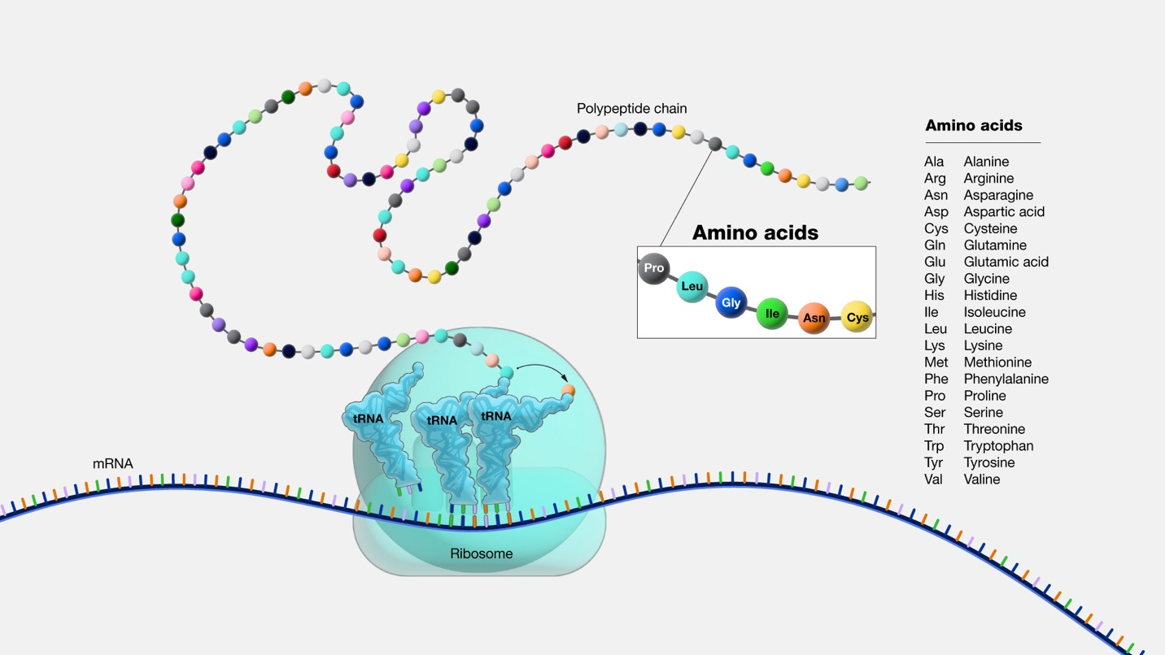

- File Formats
- FASTA format:
>Sequence_ID Description
ATGCTAGCTAGCTAGCTA
- GenBank format: includes annotation (gene name, organism, etc.).

Why Genomic Sequences Matter
- Used for disease gene discovery (e.g., sickle-cell anemia mutation).
- Comparative genomics: human vs chimp DNA.
- Forensics: DNA fingerprinting.
In 2003, completion of the Human Genome Project → “Book of Life” published for the first time.

Lab Session: Download & Explore a Gene Sequence
Objective: Learn to access and read genomic data.
- Go to NCBI Gene Database.
- Search for “TP53 human” (tumor suppressor gene).
- View sequence in FASTA format.
- Switch to GenBank format → show annotation.
- Copy-paste sequence into a text editor → highlight features.

Tasks:
- Find the sequence length (number of base pairs).
- Identify the organism’s name in the GenBank entry.

📝 Quick Review Questions
- What is a genome?
- What’s the difference between FASTA and GenBank formats?
- What base replaces “T” in RNA?

